TASK 1:
#include<iostream>
using namespace std;
class Vehicle{
protected:
string model;
double rate;
public:
Vehicle(string model ,double rate ): model(model), rate(rate){};
virtual double getDailyRate() = 0;
virtual void displayDetails() = 0;
};
class Car:public Vehicle{
double Dailyrate;
public:
Car(string model ,double rate , double Dailyrate):Dailyrate(Dailyrate),Vehicle(model,rate){};
double getDailyRate ()override{
return Dailyrate;
}
void displayDetails()override{
cout <<"\n CAR \n Daily Rate : "<< Dailyrate <<"\n model : "<<model <<"\n rate : "<<rate<<endl;
}
};
class Bike:public Vehicle{
double Dailyrate;
public:
Bike(string model ,double rate , double Dailyrate):Dailyrate(Dailyrate),Vehicle(model,rate){};
double getDailyRate()override{
return Dailyrate;
}
void displayDetails()override{
cout <<"\n Bike \n Daily Rate : "<< Dailyrate <<"\n model : "<<model <<"\n rate : "<<rate<<endl;
}
};
int main(){
Vehicle *v;
Car c1("ferrari" , 23.0 , 43.0);
v= &c1;
v->displayDetails();
cout << v->getDailyRate();
}
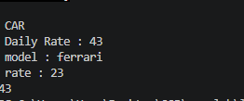
TASK 2:
#include<iostream>
using namespace std;
class SmartDevice{
protected:
bool isOn;
public:
SmartDevice(bool isOn):isOn(isOn){};
virtual void turnon(double function) = 0;
virtual void turnoff() = 0;
virtual void status() = 0;
};
class lightbulb:public SmartDevice{
double brightness;
public:
lightbulb(bool isOn , double brightness):brightness(brightness),SmartDevice(isOn){};
void turnon(double function){
isOn =1;
brightness =function;
}
void turnoff(){
isOn =0;
brightness = 0.0;
}
void status(){
cout<<"\n Status \n power : "<< isOn <<"\n brightness : "<< brightness<<endl;
}
};
class Thermostate:public SmartDevice{
double temperature;
public:
Thermostate(bool isOn , double temperature):temperature(temperature),SmartDevice(isOn){};
void turnon(double function){
isOn =1;
temperature =function;
}
void turnoff(){
isOn =0;
temperature= 0.0;
}
void status(){
cout<<"\n Status \n power : "<< isOn <<"\n temperature : "<< temperature<<endl;
}
};
int main(){
SmartDevice *s[2];
s[0] = new lightbulb(0 , 0);
s[1] = new Thermostate(0 , 0);
s[0]->turnon(20);
s[0]->status();
s[0]->turnoff();
s[1]->turnon(30);
s[1]->status();
s[1]->turnoff();
}
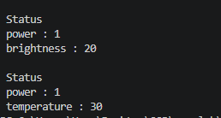
TASK 3:
#pragma once
#include <string>

class Book {
private:
std::string title;
std::string author;
std::string ISBN;

public:
Book(const std::string& title, const std::string& author, const std::string& ISBN)
: title(title), author(author), ISBN(ISBN) {}

std::string getTitle() const { return title; }
std::string getAuthor() const { return author; }
std::string getISBN() const { return ISBN; }
};
#include <iostream>
#include <string>
#include "Book.h"

class Library {
private:
static const int MAX = 10;
Book* books[MAX];
int count;

public:
Library() : count(0) {
for (int i = 0; i < MAX; i++)
books[i] = nullptr;
}

~Library() {
for (int i = 0; i < count; i++)
delete books[i];
}

void addBook(const std::string& title, const std::string& author, const std::string& ISBN) {
if (count < MAX) {
books[count++] = new Book(title, author, ISBN);
std::cout << "Added: \"" << title << "\"\n";
} else {
std::cout << "Library is full.\n";
}
}

bool removeBook(const std::string& ISBN) {
for (int i = 0; i < count; i++) {
if (books[i]->getISBN() == ISBN) {
std::cout << "Removed: \"" << books[i]->getTitle() << "\"\n";
delete books[i];
books[i] = books[--count];
books[count] = nullptr;
return true;
}
}
std::cout << "Book not found.\n";
return false;
}

void searchBook(const std::string& title) const {
for (int i = 0; i < count; i++) {
if (books[i]->getTitle().find(title) != std::string::npos) {
std::cout << "Found: \"" << books[i]->getTitle()
<< "\" | Author: " << books[i]->getAuthor()
<< " | ISBN: " << books[i]->getISBN() << "\n";
return;
}
}
std::cout << "\"" << title << "\" not found.\n";
}

void displayAll() const {
if (count == 0) {
std::cout << "No books in the library.\n";
return;
}
std::cout << "\n--- Library (" << count << " books) ---\n";
for (int i = 0; i < count; i++) {
std::cout << i + 1 << ". \"" << books[i]->getTitle()
<< "\" | " << books[i]->getAuthor()
<< " | " << books[i]->getISBN() << "\n";
}
std::cout << "---------------------------\n";
}
};

int main() {
Library lib;

lib.addBook("The Great Gatsby", "F. Scott Fitzgerald", "978-0-7432-7356-5");
lib.addBook("To Kill a Mockingbird", "Harper Lee", "978-0-0613-5527-2");
lib.addBook("1984", "George Orwell", "978-0-4517-2484-3");
lib.addBook("Brave New World", "Aldous Huxley", "978-0-0699-2840-8");

lib.displayAll();

std::cout << "\n--- Search ---\n";
lib.searchBook("1984");

std::cout << "\n--- Remove ---\n";
lib.removeBook("978-0-0613-5527-2");

lib.displayAll();

return 0;
}
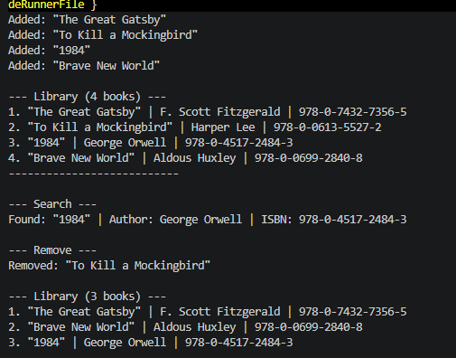
TASK 4:
#include <iostream>
#include <string>

using namespace std;

class PaymentMethod {
public:
virtual ~PaymentMethod() = default;
virtual bool processPayment(double amount) = 0;
};

class CreditCard : public PaymentMethod {
private:
string cardNumber;
public:
CreditCard(const string& number) : cardNumber(number) {}

bool processPayment(double amount) override {
if (cardNumber.empty() || cardNumber.length() < 12) {
cout << "CreditCard payment failed: invalid card number.\n";
return false;
}
if (amount <= 0) {
cout << "CreditCard payment failed: invalid amount.\n";
return false;
}

cout << "CreditCard payment successful: $" << amount << " charged to card " << cardNumber << ".\n";
return true;
}
};

class DigitalWallet : public PaymentMethod {
private:
double balance;
public:
DigitalWallet(double initialBalance) : balance(initialBalance) {}

bool processPayment(double amount) override {
if (amount <= 0) {
cout << "DigitalWallet payment failed: invalid amount.\n";
return false;
}
if (amount > balance) {
cout << "DigitalWallet payment failed: insufficient funds. Balance is $" << balance << ".\n";
return false;
}

balance -= amount;
cout << "DigitalWallet payment successful: $" << amount << " deducted. Remaining balance: $" << balance << ".\n";
return true;
}
};

int main() {
CreditCard visa("4111111111111111");
DigitalWallet wallet(100.00);

cout << "Simulating payments...\n";

double amount1 = 45.50;
if (visa.processPayment(amount1)) {
cout << "Transaction 1 completed.\n";
}

double amount2 = 75.25;
if (!wallet.processPayment(amount2)) {
cout << "Transaction 2 failed. Trying smaller amount...\n";
wallet.processPayment(50.00);
}

CreditCard invalidCard("123");
invalidCard.processPayment(25.00);

return 0;
}

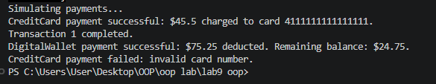
TASK 5:
include <iostream>
#include <iomanip>

using namespace std;

class Activity {
public:
virtual ~Activity() = default;
virtual double calculateCaloriesBurned() const = 0;
};

class Running : public Activity {
private:
double distance; // kilometers
double time; // minutes
public:
Running(double distanceKm, double timeMin)
: distance(distanceKm), time(timeMin) {}

double calculateCaloriesBurned() const override {
if (distance <= 0 || time <= 0) {
return 0.0;
}
// Approximate calories burned for running: 60 kcal per kilometer
return distance * 60.0;
}
};

class Cycling : public Activity {
private:
double speed; // km/h
double time; // hours
public:
Cycling(double speedKmh, double timeHours)
: speed(speedKmh), time(timeHours) {}

double calculateCaloriesBurned() const override {
if (speed <= 0 || time <= 0) {
return 0.0;
}
// Approximate calories burned for cycling based on speed and duration
return speed * time * 25.0;
}
};

int main() {
Running runSession(8.5, 50.0);
Cycling cycleSession(22.0, 1.5);

cout << fixed << setprecision(2);
cout << "Running activity: " << runSession.calculateCaloriesBurned() << " calories burned.\n";
cout << "Cycling activity: " << cycleSession.calculateCaloriesBurned() << " calories burned.\n";

return 0;
}

